**PHYTOHORMONES (DISCOVERY ANS STRUCTURE)**

Plant growth regulators are chemical substances which in low concentration regulate growth, differentiation and development in plants. These molecules are manufactured by plants to accelerate, inhibit or modify its growth and are also known as plant hormones or phytohormones or plant growth substances

The term plant growth substances rather than plant hormone are used by various plant physiologists because it can include both endogenous (native) and exogenous (synthetic) substances found to modify plant growth. Those substances produced by the plant are called phytohormones where as others are known as synthetic plant growth substances.

**TYPES**: The five most well-known hormones are:

1. **AUXINS**
2. **GIBBERELLINS**
3. **CYTOKININ**
4. **ETHYLENE**
5. **ABSCISIC ACID**

All are in some way involved in regulating plant growth and development. Some promote growth by stimulating cell enlargement or division while others inhibit growth by inducing dormancy or promoting senses.

**PRINCIPLES OF HORMONE FUNCTION:**

Two or more hormones work synergistically often or sometimes they work antagonistically. Skooge and Miller (1957) provided evidence that Auxins and Cytokinins work together in the differentiation of plant organs in tobacco tissue culture whereas in others, they work antagonistically- Auxins (Apical dominance) and Cytokinins (Lateral dominance).

**AUXINS**

Auxins are one of the most important groups of plant hormones because of their many sided roles in plants. The term auxin is derived from Greek word “auxein” which means to grow. Auxin includes all those chemical substances which promote growth of stem or coleoptile sections and decapitated celeoptiles, but in the same concentrations are incapable of causing growth on intact plant. The principal naturally occurring auxin is Indole 3-acetic acid (IAA). Other auxins are Indole 3-pyruvic acid, Indole 3-ethanol, Indole 3-acetaldehyde etc. In addition to these, certain synthetic auxins are also known. These are 2, 4- dichlorophenoxyacetic acid (2, 4 D), 2,4,5 Trichlorophenoxy acetic acid (2,4,5-T). Indole butyric acid (IBA) and naphthalene acetic acid (NAA), etc..

**HISTORY AND DISCOVERY OF AUXINS**

The first indication of the existence of growth hormones came from the work of Charles Darwin (1880) and his son while working on Canary grass (*Phalaris camariensis*) demonstrated the bending of grass coleoptile towards unilateral source of light. The bending occurred only when the tip of coleoptile was illuminated. Decapitating or covering the tip with black cap resulted in loss of sensitivity of the plant towards light. Replacement of tip caused bending. This showed that the tip of the coleoptile perceived the light and then exerted some influence on differential growth in the non-illuminated side.

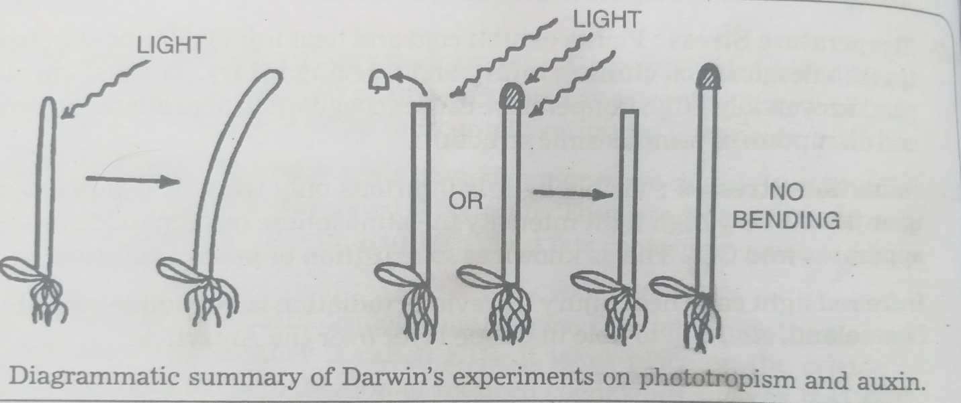

Earlier Ciesielski (1872), a horticulturist, working with roots had also drawn a similar conclusion. According to him a growth substance present in the tip was responsible for the growth in the zone of cell elongation.

Subsequently, **Boysen-Jensen** (1913) was able to show that the stimulus could be transmitted through agar blocks but not through pieces of mika. He decapitated the seedling of Avena, smeared a bit of gelatin on the cut end, re-placed the tip on the gelatin and found that coleoptile bends towards light source. The conclusion drawn from the simple experiment was that some substance has diffused from the tip through gelatin to the cut end where it caused growth. Paal (1918) demonstrated that if the decapitated tip was replaced on the cut end eccentrically, more growth resulted on that side which caused bending even though this was done in complete darkness.

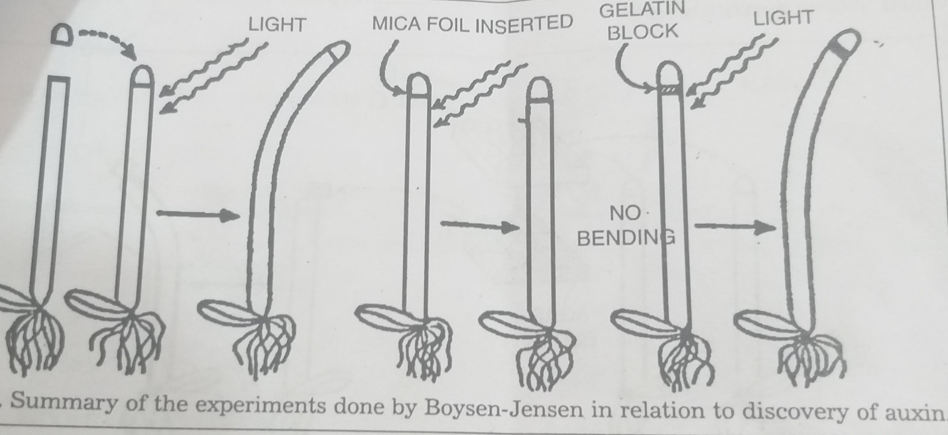

About the kinds of auxins, Indole 3-acetic acid is the most well studied and important natural auxin. The natural auxins are synthesized at the apices of roots, shoots, their branches, young leaves and cotyledons.

**MOLECULAR STRUCTURE OF AUXINS**

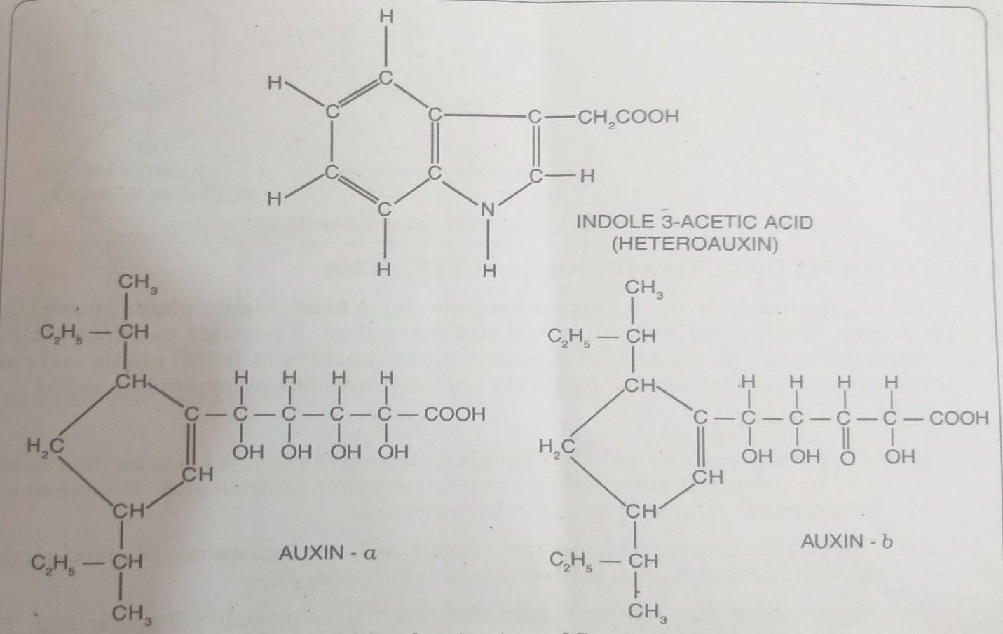

**MOLECULAR STRUCTURE OF SYNTHETIC AUXINS**

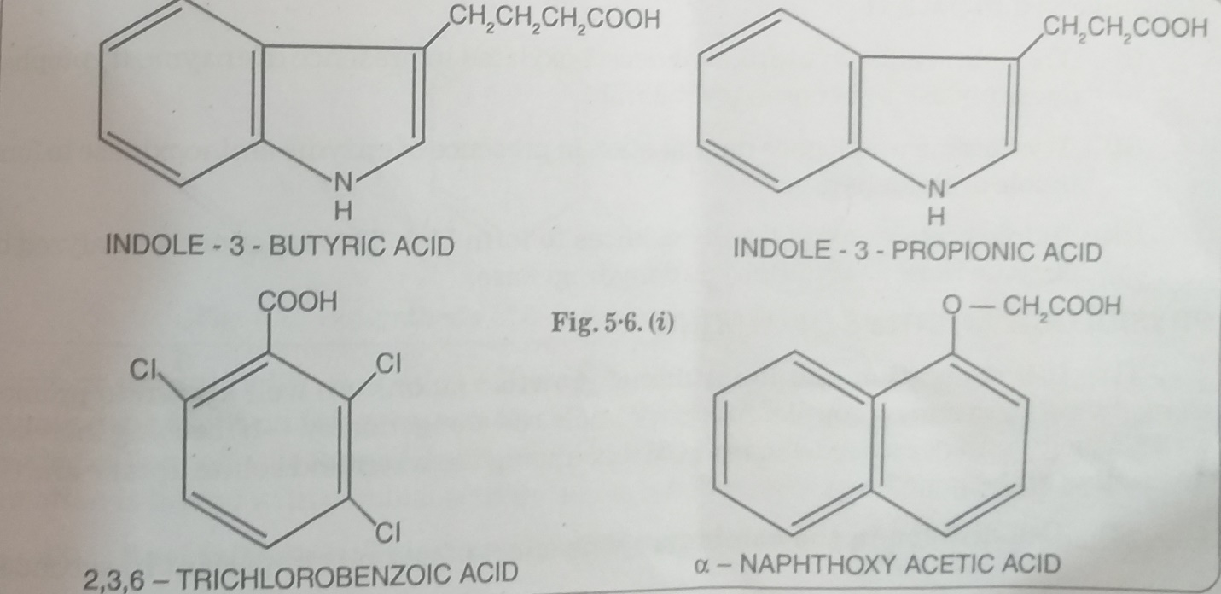

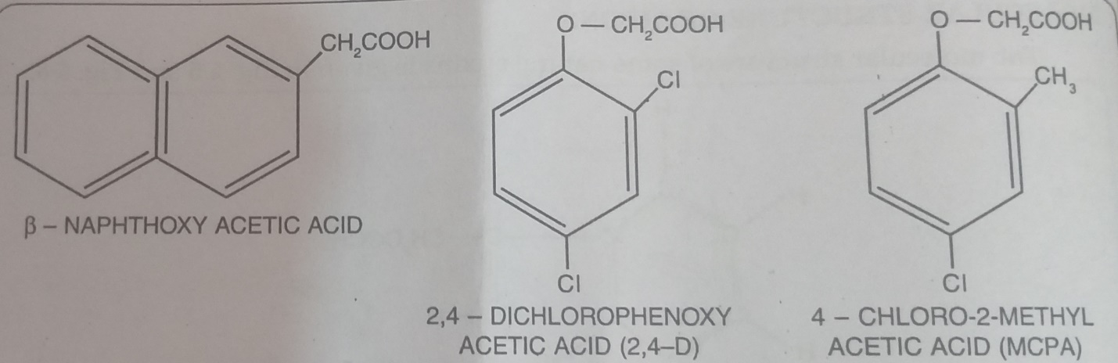

**THE CHEMICAL STRUCTURE OF SOME SYNTHETIC AUXINS**

**BIOSYNTHESIS OF AUXINS (INDOLE 3-ACETIC ACID)**

An extensive study made in micro-organisms and in many higher plants showed that auxin (IAA) is synthesized from an amino acid tryptophan. A possible pathway is shown in the diagram. Detailed studies made in different plants and plant parts indicated at least 2 separate pathways in the conversion of tryptophan to IAA.

**STEPS INVOLVED IN PATH 1**

1. First of all the amino acid tryptophan donates its amino group to another α-keto acid by transamination reaction to become indole pyruvic acid. The reaction is cataylsed by enzyme tryptophan transaminase.
2. Then indolepyruvic acid undergoes decarboxylation in presence of enzyme indole pyruvate decarboxylase to become indole acetaldehyde.
3. Finally indole acetaldehyde gets oxidised to become indole 3-acetic acid. This reaction is catalysed by enzyme indole acetaldehyde dehydrogenase.

**STEPS INVOLVED IN PATH 2**

1. The amino acid tryptophan is decarboxylated in presence of enzyme tryptophan decarboxylase to become tryptamine.
2. Tryptamine undergoes deamination in presence of enzyme amino-oxidase to form indole acetaldehyde.
3. Indole acetaldehyde finally oxidizes to form IAA. This reaction is catalysed by enzyme indole acetaldehyde dehydrogenase.

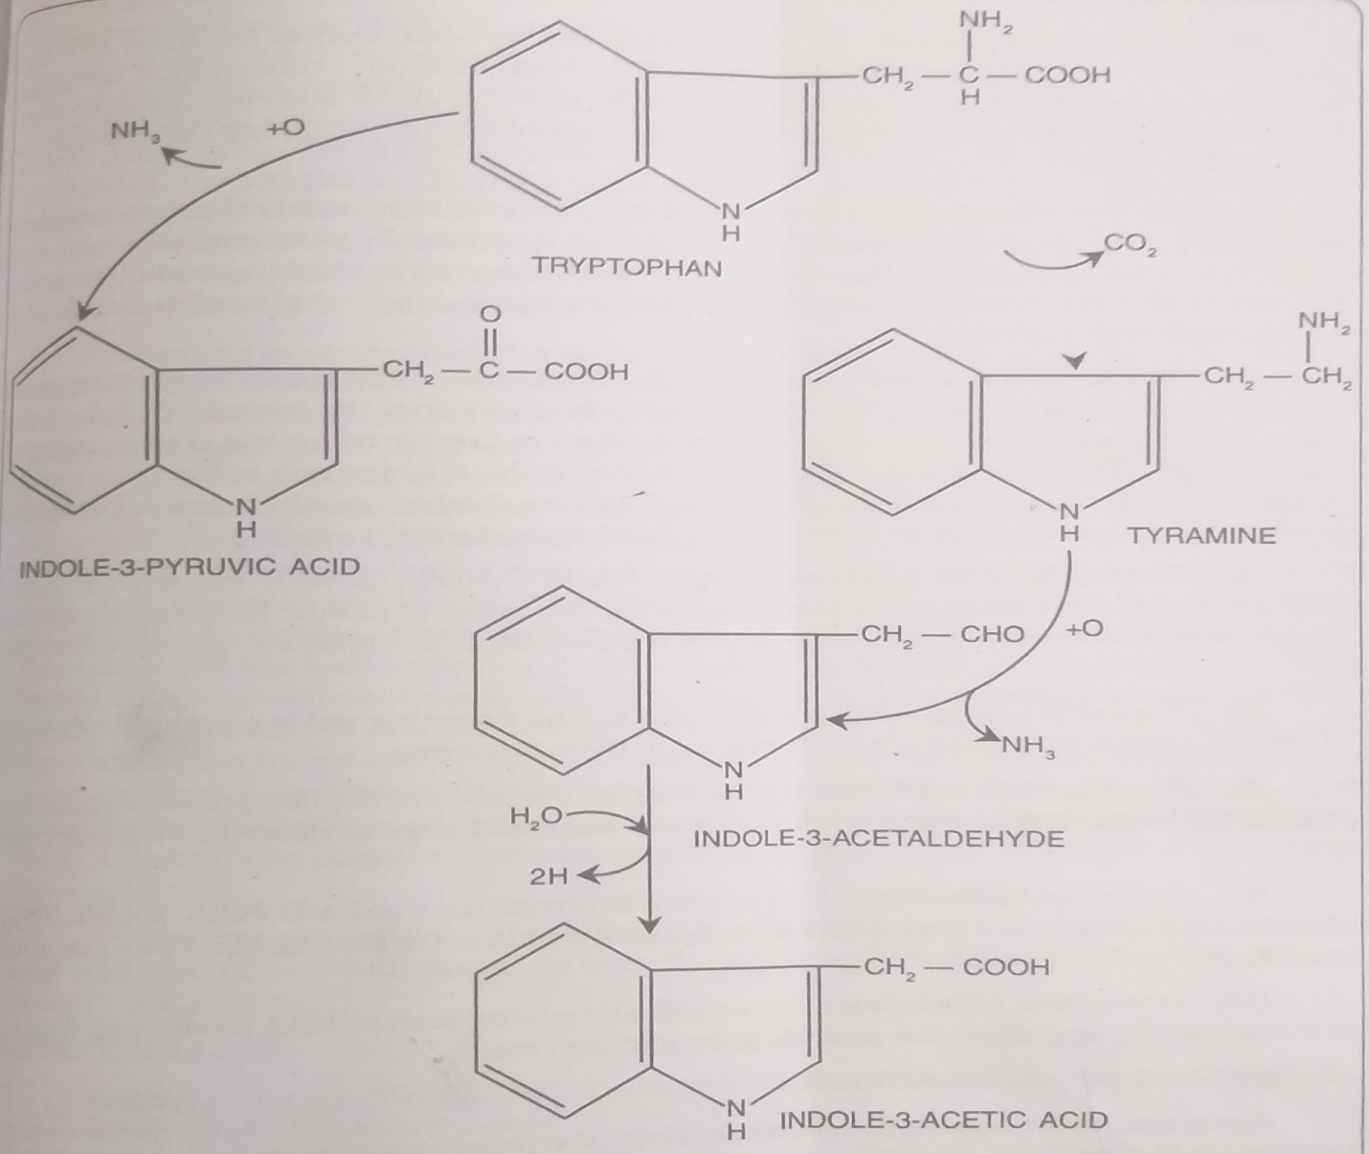

**BIOSYNTHESIS OF β-INDOLE 3-ACETIC ACID FROM TRYPTOPHAN**

**PHYSIOLOGICAL ROLES OF AUXINS**

1. **CELL ELONGATION AND LONGITUDINAL GROWTH**

Auxins are well known to promote elongation of stem and coleoptile. Auxins promote cell elongation by

-causing increased wall plasticity with decreased elasticity.

-enhancing the water and solute uptake.

-interacting at the gene level.

1. **CELL DIVISION IN THE CAMBIUM**

This effect of auxin is important in secondary growth of stem and differentiation of xylem and phloem. In tissue culture cell division is entirely dependent on the presence of auxin. Whenever wound is caused in the plants, a swelling called callus is formed due to the proliferation of parenchymatous cells. The callus formation is linked with cambial activity which is believed to be stimulated by auxin.

1. **ROOT INITIATION**

This property of auxin has been exploited in the propagation of plants by cuttings in nurseries.

1. **APICAL DOMINANCE**

In most plants, the terminal bud at the apex of a shoot suppresses the development of lateral buds. This phenomenon is called apical dominance and is due to the presence of auxin at the apex. Removal of apical bud causes fast growth of lateral buds. The auxin of terminal bud is thus responsible for inhibiting the development of lateral buds.

1. **PREVENTION OF ABSCISSION LAYER**

The formation of abscission layer often results in the premature fall of leaves and fruits. Auxin inhibits the formation of abscission layer. Abscission layer cuts off nutrient and water supply.

1. **PRODUCTION OF PARTHENOCARPIC FRUITS**

Auxin is well known to induce parthenocarpy i.e. formation of seedless fruits in a number of plants. External application of auxins on flowers causes development of seedless fruits in tomatoes, apples, cucumber, etc.

1. **FLOWER INITIATION**

Auxins generally inhibit flowering but in pine apple spraying of certain auxins initiates uniform flowering in the whole crop.

1. **PLANT GROWTH MOVEMENTS**

Auxins regulate some of the important plant growth movements like phototropism, geotropism and thigmotropism as described earlier in this unit.

1. **AUXINS AS HERBICIDES**

Some synthetic auxins are used as selective herbicides in controlling weeds in the crop fields. They are widely used as potent defoliants.

1. **PREVENTION OF LODGING**

Some synthetic auxins such as NAA have been found to prevent lodging and allow the plant to grow stiff and erect.

**MECHANISM OF AUXIN ACTION**

Auxin (Indole 3-acetic acid) causes cell extension by

1. Decreasing the osmotic potential of the cell.
2. Increasing the permeability of the cell to water
3. Inducing synthesis of enzyme for wall components.
4. Causing reduction in wall pressure.

**GIBBERELLINS**

Gibberellins are plant growth hormones which enhance the longitudinal growth of stem when applied to intact plants.

**DISCOVERY OF GIBBERELLINS**

The history of the discovery of gibberellins dates back to the 19th century when the Japanese farmers noticed that certain diseased plants grew abnormally thin and tall. They called it “Bakanae or foolish seedling” disease because it made the young rice plants grows ridiculously tall. Infection by the fungus *Fusarium monoliforme*, the imperfect stage of *Gibberella fujikuroi* was shown to be responsible for the disease. Sawada (1912) hinted that the disease might be caused by something secreted by the fungus. Kurosowa (1926) performed experiments to demonstrate that filtrates of the culture of the fungus produced the characteristic symptoms, when applied to healthy seedlings of rice. In 1938, Yabuta and Sumiki finally succeeded in isolating a pure crystalline chemical, which they named “gibberellin”. These remarkable works of the Japanese remained unnoticed outside Japan for quite some time due to the World War 2. It was only after 1950 that anyone outside Japan began to study the gibberellins. Among the first were Stodola and his group in Ilinois and P.W. Brian (1955) and his associates at the Imperial Chemical Industries in England.

Cross et. Al (1961) isolated 6 gibberellins from the fungus Gibberella and they were termed GA1, GA2, GA3, GA4, GA7, and GA9. MacMillan et. al(1961) isolated three gibberellins from bean seeds. They were termed GA5, GA6 and GA8. As and when additional gibberellins discovered they are assigned numbers. The number of gibberellins discovered now stands at more than 100, out of which 25 have been isolated from Gibberella fujikuroi only. They are chemically known as gibberellic acid. They have gibbane ring skeleton. In many plants, gibberellins have been discovered which are neutral and are not acidic like other gibberellins. Hasimoto and Rappaport, working with radioactive GA, found evidence that they are actually acidic gibberellins whose carboxyl groups were marked by esterification.

Gibberellins have been reported to occur in several plant organs such as roots, stems, leaves, buds, flower buds, root nodules, fruits, immature seeds and callus tissues of higher plants.

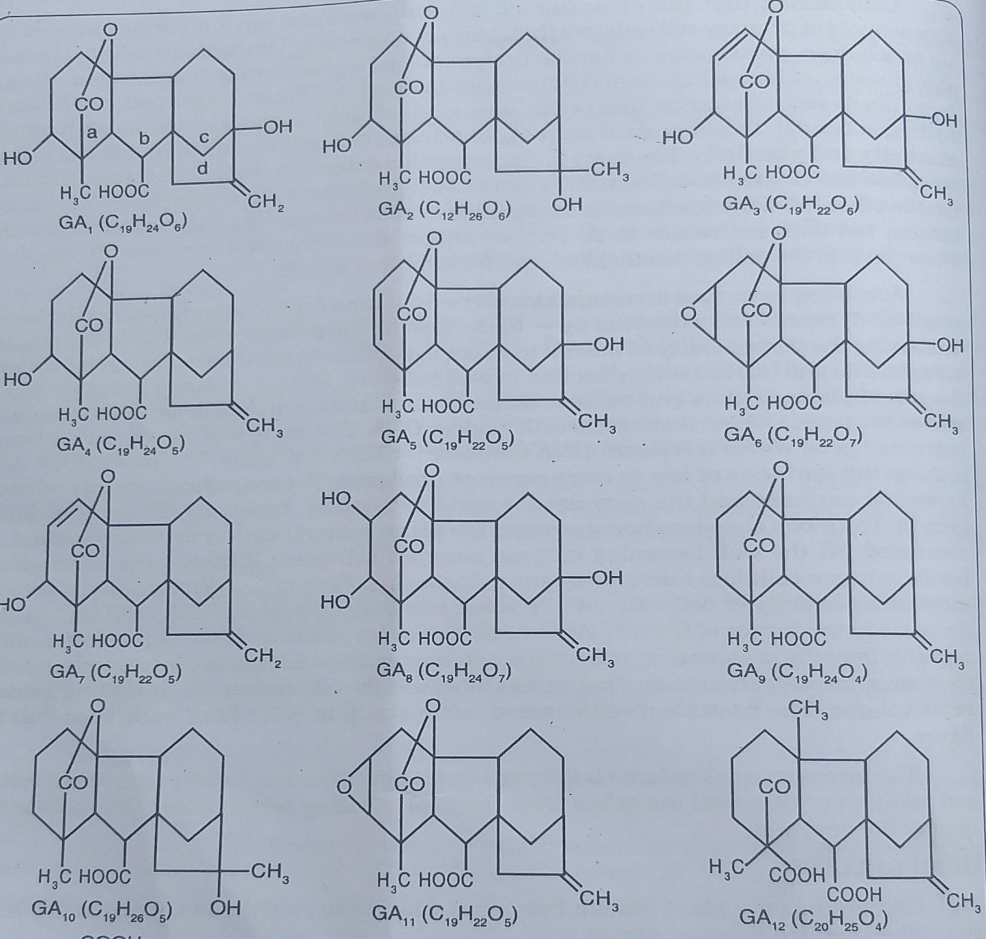

**CHEMICAL STRUCTURE OF NATURALLY OCCURING GIBBERELLINS**

**CHEMICAL COMPOSITION**

All types of gibberellins, known so far bear the gibbane skeleton. The individual gibberellins differ in their side attachments of various groups such as –OH group, -COOH group.

BIOSYNTHESIS

Gibberellins are synthesized through the normal isoprenoid pathway of terpene biosynthesis starting with acetate which is the precursor. The first few step in gibberellin biosynthesis involve the transfer of active acetyl groups and formation of three acetyl Co-A molecules and their eventual condensation to form mevalonic acid which is then phosphorylated into mevalonic acid pyrophosphate in presence of ATP and a kinase enzyme. Decarboxylation of pyrophosphate yields isopentenyl pyrophosphate (IPP), a five carbon isoprenoid unit forms which gibberellins, ABA, a portion of Cytokinins and all carotenoids are derived.

Isomerization of IPP to dimethylallyl pyrophosphate constitutes the first step towards the synthesis of higher terpenoids. This compound acts as accepter of one molecule of IPP to form a 10-carbon compound geraniol pyrophosphate. 2 successive additions of IPP units to geranylgeraniol pyrophosphate (20-C) which is then converted first into diterpene alcohol copalyl pyrophosphate and then to kaurene. Kaurene can be readily converted into gibberellin in the plant.

**PHYSIOLOGICAL ROES OF GIBBERELLINS**

A variety of responses have been observed in plants by the application of gibberellins as are discussed below:

1. **STEM ELONGATION**

The most typical and striking effect of gibberellins is on the elongation of the stem. The internodes increase in length. In lettuce plant, a low head becomes vine like after it is treated with gibberellins.

1. **REVERSAL OF DWARFISM**

One of the most remarkable effect of gibberellins is in the converting a genetically dwarf plant into a plant of normal height. Addition of gibberellin to a cabbage plant converts the head or dwarf stem in to a stem which is 6-8 feet tall.

1. **PROMOTING FLOWERING IN LONG DAY PLANTS**

Gibberellins have been found to promote flowering in a class of plants called long day plants under unfavorable short day conditions.

1. **SUBSITUTING COLD TREATMENT**

Biennials normally flower only during the second year of growth i.e. only after it has passed through a winter season. Many biennial plants can be induced to complete their whole life cycle and hence the period of flowering in a single year by treatment with gibberellins.

1. **PARTHENOCARPIC FRUITS**

Gibberellins have been found to be more effective than auxins in causing parthenocarpic development of fruits in plants like tomatoes, apples, pears.

1. **BREAKING DORMANCY**

Gibberellins have been shown to be effective in breaking the dormancy in potato tubers and in tree buds in winter.

1. **SEED GERMINATION**

Some of the higher sensitive seeds e.g. *Lactuca sativa*, barley etc. can germinate with the treatment of gibberellin even in complete darkness which otherwise require specific light conditions.

1. **CELL DIVISION IN CAMBIUM**

Gibberellin can stimulate cell division in the vascular cambium of many deciduous trees in spring season.

**MECHANISM OF ACTION OF GIBBERELLINS**

Gibberellins have been studied in relation to their effect on the 3 regions of growth of the stem apex, viz. the zone of apical meristem, the zone of sub-apical meristem and the elongation zone. The 3 regions of the stem have been found to differ in their response to gibberellins.

The activity of apical meristem is quite independent of the presence or absence of gibberellin. In certain cases, the gibberellin has been shown to be effective in protecting the apical meristem from the inhibitory effect of endogenous growth inhibition such as **dormin**. In such cases the dormancy has been reversed by the addition of gibberellins.

Gibberellins promote shoot growth mainly by accelerating the rate of cell elongation and cell division in the sub-apical meristem region where young internodes are developing.

Gibberellins have been demonstrated to be very important in the control of flowering and fruit growth.

**CYTOKININS**

Cytokinins are plant growth substances which act primarily on cell division and have little or no effect on extension growth. Chemically, Cytokinins are the derivatives of purines in which the amino acid in position 6 bears furfuryl substituent-6-furfuryl amino purine. Zeatin is a naturally occurring one.

**DISCOVERY**

Gautheret (1939), Nobecourt (1939) and White (1939) were the firsts to report the success of plant tissue cultures. Skoog and Tsui (1948) working on the culture of stem internode segments of *Nicotiana tabaccum* found an auxin such as Indole 3-acetic acid to be indispensable for their growth. Jablonski and Skoog (1954) reported that a substance present in the vascular tissue was responsible for causing cell division in the pith cells. Miller (1954) was the first to isolate the first crystals of a cell division inducing substance from autoclaved herring sperm DNA. Later Miller et.al found this substance to be very effective in causing cell division even in very low concentrations (1 part per billion) when auxin was also present in the medium. Since the substance had specific effect on cytokinesis, it was named Kinetin. The term Cytokinin proposed by Letham (1963) is the most acceptable one. Cytokinins mostly occur in seeds.

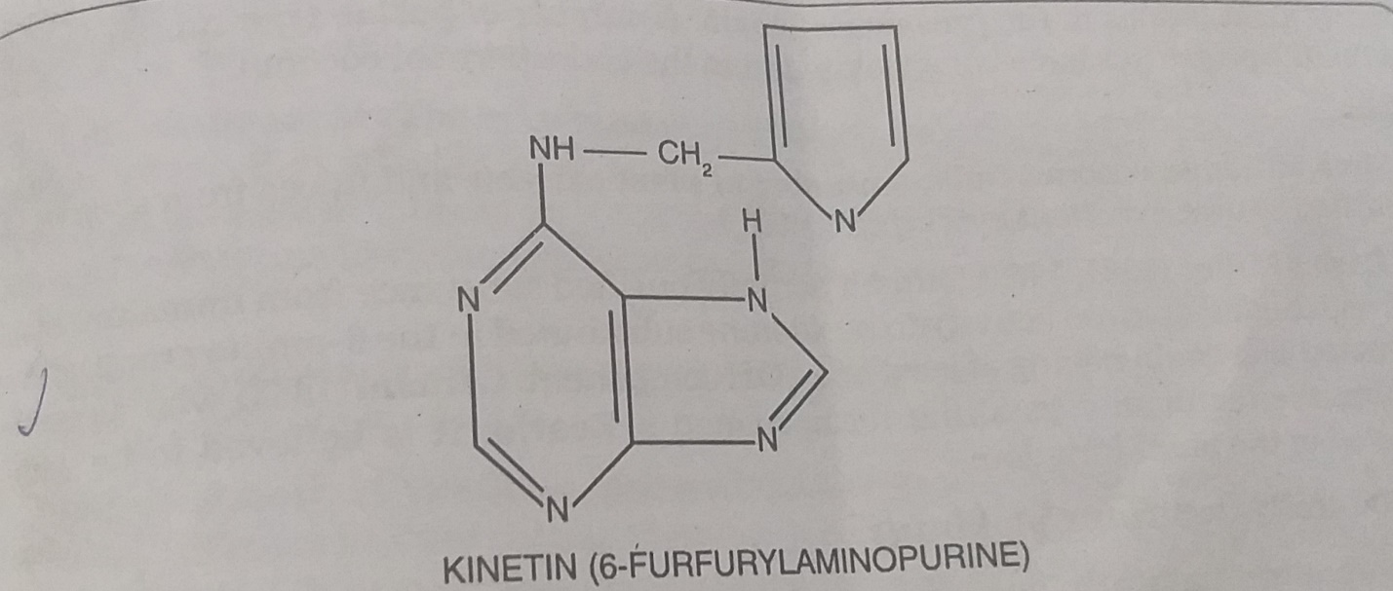

**STRUCTURE OF KINETIN**

Kinetin has been found to be a derivative of the purine base adenine which bears furfuryl substituent at the 9th position which migrated to the 6th position of the adenine ring during autoclaving of DNA. Now it is known that Cytokinins are a part of tRNA.

All the cytokinins have purine (adenine) ring with a side chain at N6 position (amino substitute). Several workers found certain substituted purine derivative to be more effective than kinetin.

Kinetin and auxin applied separately to tissue culture produce small increase in the growth of the tissue but in combination they stimulate a tremendous increase in the mitotic activity. **Cell division mainly occurs by Kinetin, cell enlargement is induced by Auxin. Kinetin promotes cell enlargement, promotes or inhibits root initiation and helps in breaking dormancy.**

**MECHANISM OF ACTION OF CYTOKININS**

1. They increase the content of cellular RNA and protein.
2. Promote the synthesis of some enzymes and suppress the activity of other enzymes (viz. the nucleic acid degrading enzymes, ribonuclease and deoxyribonuclease)
3. Kinetin preserves protein in detached leaves by increasing RNA and protein synthesis.

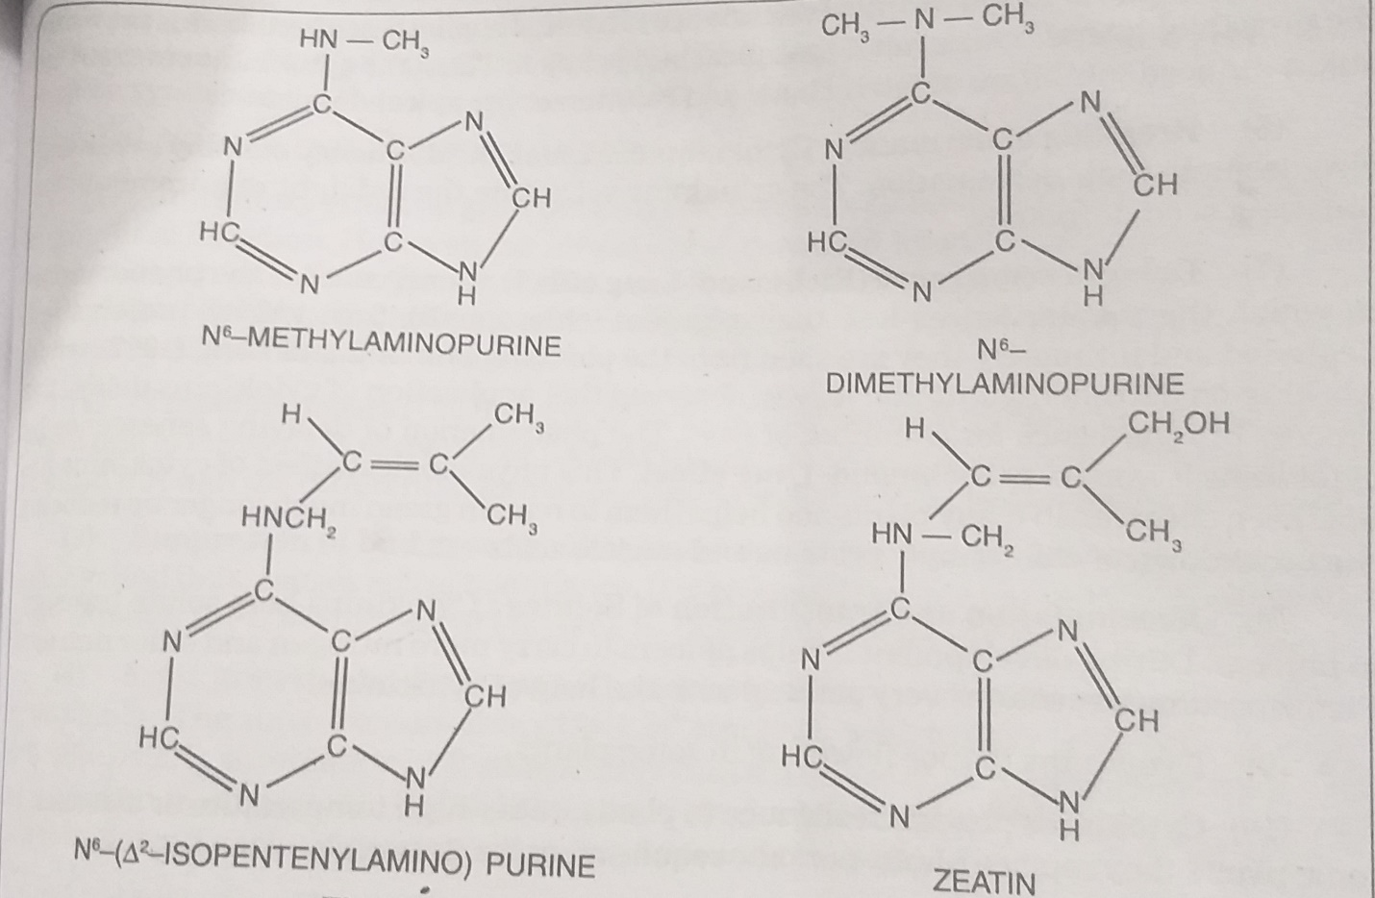

**SOME NATURALLY OCCURRING CYTOKININS**

**PHYSIOLOGICAL ROLES OF CYTOKININS**

1. **CELL DIVISION**

Of all the growth hormones, cytokinins have been found to be a true cell division factor in a number of plants. The varying amount of cytokinins along with auxins is required for the growth of callus in tissue culture.

1. **CELL ENLARGEMENT**

The cytokinins can also cause the enlargement of cells in leaf discs and cotyledons. This effect of kinetin can occur in the absence of auxin. Cell enlargement is due to stimulated water up take and partly due to increased plasticity if cell walls.

1. **INITIATION OF INTERFASCICULAR CAMBIUM**

The cytokinins can induce the formation of interfascicular cambium in plants.

1. **MORPHOGENESIS**

Cytokinins oppose initiation of roots in stem cuttings treated with auxin and result in the formation of callus at the cut end. Auxin-Cytokinin interaction controls the morphogenetic differentiation of shoot and root meristems.

1. **COUNTERACTION OF APICAL DOMINANCE**

External application of cytokinins promotes the growth of lateral buds even if the apical bud is intact. Thus, cytokinins reverse the auxin induced inhibition of lateral buds and counteract the apical dominance

1. **BREAKING OF DORMANCY**

Cytokinins can break the dormancy of many seeds and also promote their generation. The cytokinins substitute the red light requirement for breaking seed dormancy.

1. **DELAY OF SENESCENCE (RICHMOND LANG EFFECT)**

Senescence is the phenomenon in which the mature leaves lose their pigment (Chlorophyll), turn yellow, proteins are degraded and ultimately they are shed from the plants. Richmond and Lang while working on detached Xanthium leaves, observed that application of cytokinins delays the process of senescence for a number of days. This is called Richmond and Lang effect.

1. **ACCUMULATION AND TRANSLOCATION OF SOLUTES.**

Cytokinins help solute transport in phloem. During development, it helps phloem to carry nitrogen and other nutrient. Plants accumulate solutes very actively with the help of cytokinins.

1. **Cytokinins induce flowering in some plants.**
2. **Cytokinins provide resistance to plants under high temperature or diseases. In some plants they replace photo-periodic requirement for flowering.**

**ETHYLENE**

Ethylene is a volatile gaseous compound synthesized in ripening fruits, flowers, leaves and even roots and acts as a natural plant growth hormone. In leaves it is a powerful inducer of senescence. In fruits, it promotes ripening.

**DISCOVERY**

The discovery of ethylene as plant growth hormone dates back to 1901 when Nelyubow found that ethylene gas alters the trophic responses of roots. Denny (1924) observed that ethylene gas was highly effective in inducing fruit ripening. Zimmerman (1931), found that ethylene induces leaf abscission. Subsequently physiological studies led to the discovery of ethylene as a natural product of ripening fruits by Gane in 1934. It is now well established that ethylene is synthesized in ripening fruits, leaves and even roots. It is usually present in minute quantity (less than 0-1 ppm) and causes marked effects.

MECHANISM OF ACTION OF ETHYLENE

1. At the nuclear level, controls the gene expression and synthesis of many enzymes.
2. In ripening fruits, the increased ethylene production has been shown to increase to enhance the synthesis of **polygalacturonases** which catalyses cell wall softening.
3. Other enzymes such as Phenylalanine ammonia lyase (impart beautiful colors of anthocyanins to the ripening fruits), cellulase (appears in abscission layer to cause cell wall degradation), and peroxidases etc. are also synthesized due to ethylene stimulus in different tissues.

**PHYSIOLOGICAL ROLES OF ETHYLENE**

1. **INHIBITORY EFFECT ON GROWTH**

Ethylene prevents elongation of stem and roots in longitudinal direction which is associated with radial enlargement of tissues. This results in swelling of plant parts.

1. **TROPIC RESPONSES**

Ethylene is responsible for the positive geotropic bending of roots. This is caused through the differential formation of ethylene on geotropically lower side of the roots.

1. **SUPPRESSION OF BUD GROWTH**

Ethylene inhibits the growth of lateral buds in pea seedlings and thus, causes apical dominance. It is proposed that auxin might be functioning partly through the biosynthesis of ethylene.

1. **FRUIT GROWTH AND RIPENING**

The growth of fruit is stimulated by ethylene in some plants. It stimulates fruit ripening which is marked in climacteric fruits. Ethylene is produced in mature but unripe fruits and then it initiates a chain of reactions that finally lead to ripening.

1. **ABSCISSION**

Ethylene stimulates the formation of a separation or abscission zone in leaves, flowers and fruits. Abscission is regulated by a balance between Auxin ( a retardant) and ethylene (a stimulant). Ethylene stimulates abscission by formation of hydrolases.

1. **FLOWERING**

Flowering in pineapple, mango and various other plants can be induced by the application of ethylene.

1. **ROOT INITIATION**

Ethylene stimulates rooting of cuttings, initiation of lateral roots and growth of root hairs. At lower concentration it promotes root growth whereas at higher concentration, it inhibits.

1. **DORMANCY**

Ethylene is responsible for breaking the dormancy of buds and seeds.

1. **LEAF BENDING (EPINASTY)**

More growth on upper surface than on lower surface of leaf causes epinasty. Such type of bending is controlled by ethylene in many plants. At higher concentration it reverses the opening movement of petals in many flowers and cause sleep disease.

1. **SENESCENCE**

Ethylene promotes the yellowing and senescence of leaves. It induces flower-fading in pollinated orchids.

**BIOSYNTHESIS OF ETHYLENE**

Lieberman, Mapson and Wardale suggested that the sulphur containing amino acid methionine is the primary natural precursor of ethylene in plants. The important features are divided into 3 steps as below:

**STEP 1**- Methionine is converted to S-adenosylmethionine (SAM) by using ATP.

**STEP 2**-SAM is converted to 1-aminocyclopropane-1-carboxylic acid (ACC). This reaction in tomato fruit is catalysed by the enzyme ACC Synthetase. This enzyme controls the rate of formation of ethylene.

**STEP 3**-The conversion of ACC to ethylene results in the production of CO2, ammonia and formic acid. The other carbon products arise respectively from the first and second carbons and ethylene comes from the third and fourth carbon of methionine. Factors that influence this reaction are factors that promote ripening and high CO2 levels that are inhibitory.

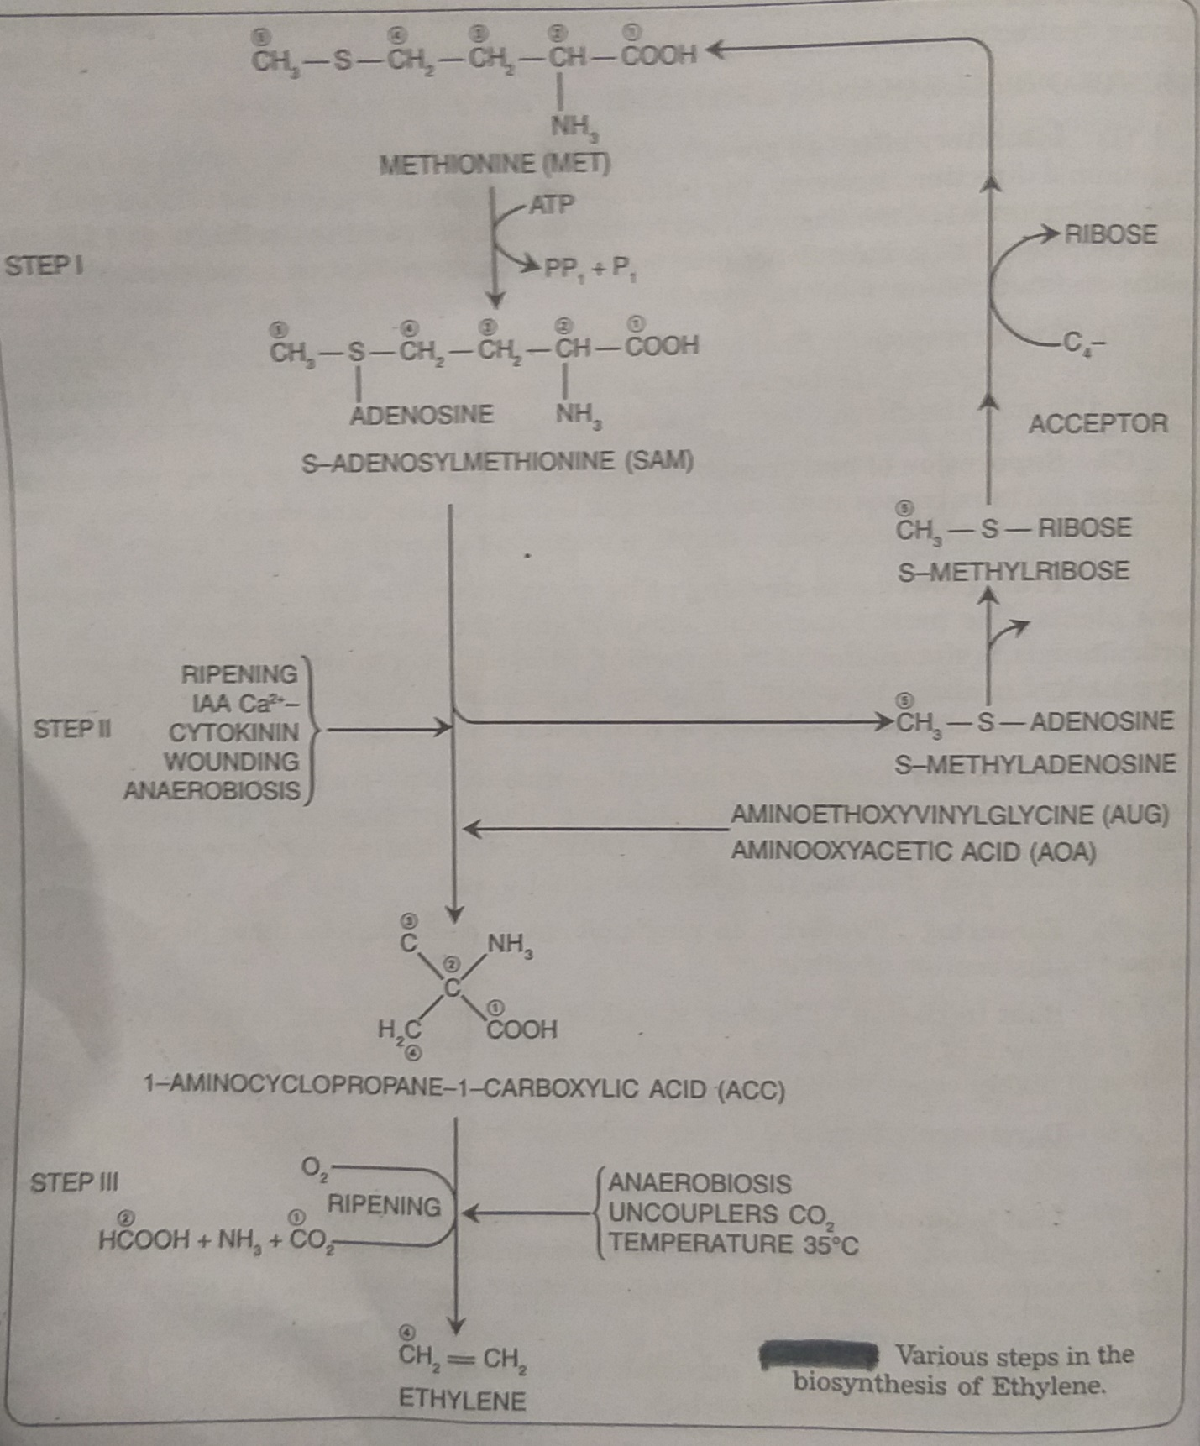

**ABSCISSIC ACID (ABA)**

ABA is a growth inhibitor and is extracted from several parts of the plant including dormant buds and seeds. ABA is a sesquiterpene consisting of 15-C and characterized by a 6 membered ring with asymmetric centre and an unsaturated 6-C substituent.

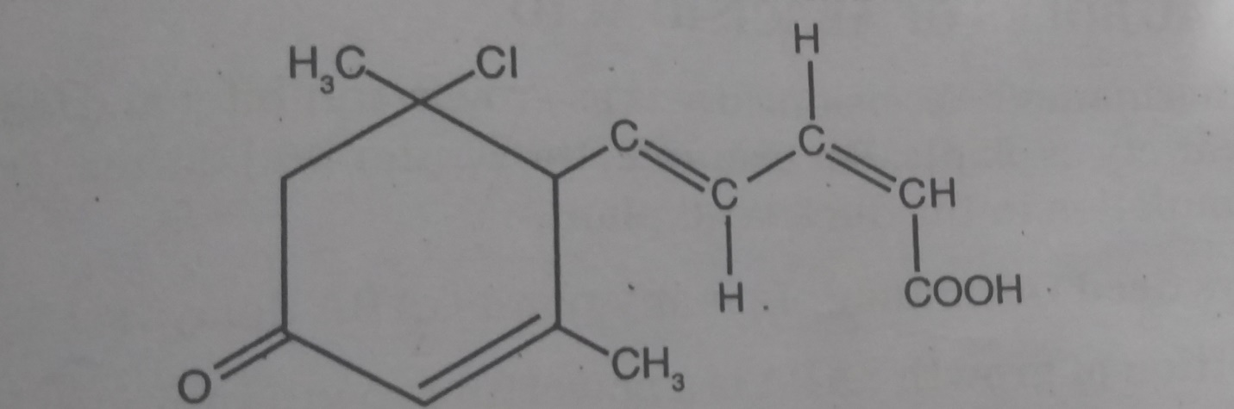

**ABSCISSIC ACID (ABA)**

**DISCOVERY**

Hemberg (1949) showed that extract of dormant potato tubers and buds of Fraxinus contain substances which inhibit the growth of Avena coleoptile and the removal of dormancy of the tubers also resulted in marked reduction in the level of inhibitors. Osborne was the first to provide evidence for the occurrence of a growth inhibiting substance in plants. She demonstrated that an extract of ageing leaves caused premature dropping young leaves of bean plant.

Robinson et.al (1963) succeeded in extracting the inhibitory substance and called it dormin. Corns and Addicot, while working on the physiological studies of the shedding of cotton balls found that the chemical substance abscissin II is responsible for their shedding. Simultaneously Wareing and Cornforth isolated substance that can induce bud dormancy; they named the substance as dormin. It was later on realized that dormin and abscissin II were the same and the substance was named as Abscisic Acid. Pure ABA gives very good Avena coleoptile test and other growth tests to show that it is highly active growth inhibitor.

**BIOSYNTHESIS OF ABA**

ABA is derived from mevalonic acid as described in the biosynthesis of gibberellins. Mevalonic acid pathway is of great importance in the synthesis of other phytohormones. Synthesis of ABA occurs in Chloroplasts.

**MECHANISM OF ACTION OF ABA**

1. It may compete with auxins, gibberellins or cytokinins for a specific enzyme site since it is known to be antagonistic to their effects.
2. It may inhibit the biosynthesis of other growth hormones or even inactivate them
3. ABA may inhibit RNA and protein synthesis.
4. It may stimulate the production of certain hydrolytic enzymes.

**PHYSIOLOGICAL ROLES OF ABSCISSIC ACID**

1. **BUD DORMANCY**

Abscissic acid acts as growth inhibitor and induces bud dormancy in a variety of plants. For example, the winter bud dormancy is induced by ABA accumulation in the duckweed plant.

1. **DELAYS SEED DORMANCY**

In many plants, ABA delays seed germination.

1. **INHIBITION OF GROWTH**

ABA is a powerful growth inhibitor. Also inhibits gibberellin stimulated growth

1. **SEED DEVELOPMENT AND GERMINATION**

ABA accumulates in embryos of developing seeds. Either it is synthesized de novo or translocated from leaves. It inhibits formation of germination enzymes in the embryo and inhibits vivipary. Treatment of exogenous ABA inhibits seed germination even in the presence of gibberellins and cytokinins.

1. **ABSCISSION**

Slight effect of ABA when applied to intact plant

1. **GEOTROPISM**

It is present in the corn (Zea mays) root caps, translocates basipetally and stimulates positive geotropic response by acting as inhibitor.

1. **STOMATAL CLOSING**

Causes closure of stomata. It inhibits K+ uptake by guard cells and promote the leakage of malic acid. It results in the reduction of osmotically active solutes that the guard cells become flaccid and stomata get closed.

1. **ROLE IN WATER STRESS**

ABA plays an important role in plants during water stress and during draught conditions. It has been observed that the concentration of ABA increases in the leaves of plants facing such stresses. It results loss of turgor and closure of stomata. Therefore, acts as stress hormone.

1. **SENESCENCE**

It promotes senescence in leaves by causing loss of chlorophyll pigment; decreasing the rate of photosynthesis and changing the metabolism of proteins and nucleic acids.

1. **COUNTERACTS THE EFFECTS OF OTHER HORMONES.**
2. ABA inhibits cell growth by IAA
3. ABA inhibits amylase produced by seed treated with gibberellin
4. ABA promotes chlorosis that is inhibited by cytokinins.